THEORY QUESTIONS
1.
(a)

Given that P = {factors of 36} and Q = {factors of 54},
(i)

list the members in the sets P and Q.
(ii)

Find:
Α

P∩Q
Β

n(P∩Q)
Γ

The Highest Common Factor (HCF) of 36 and 54.
(b)

Write down the next two terms of the sequence 1,4,9,...,...
(c)

The median of the ordered set of observations 2,3,(4m-3),(3m+1),11 and 13 in ascending order is 6. Find the value of m.

2.
(a)

Simplify:

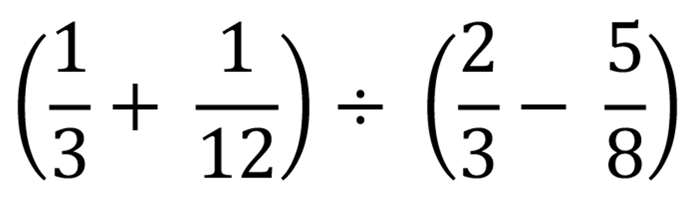
(b)

Find the product of (2x - 3) and (2x + 3).
(c)

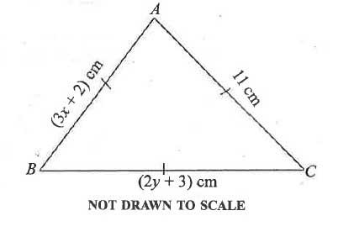
In the diagram, ABC is an equilateral triangle. Find the value of (x + y).

3.
(a)

Given the relation

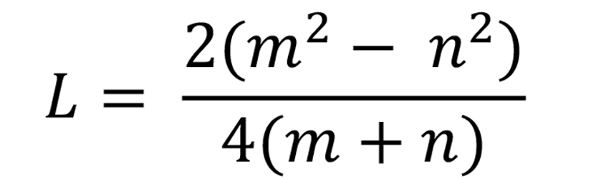
(i)

simplify L;
(ii)

find the value of L when m = 2 and n = 3.
(b)

Solve

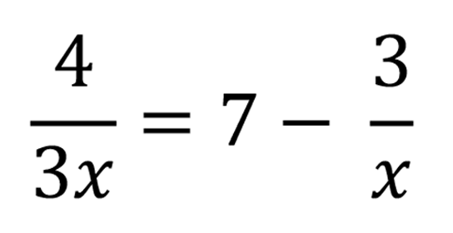

.
(c)

A salesman gets a commission of 5¹⁄₂% of the value of items he sells. The salesman sells 12 textbooks at GH₵ 25.00 per book, 3 scientific calculators at GH₵ 50.00 per calculator and 8 packets of bic pens at GH₵ 50.00 per packet. Calculate the salesman's commission.

4.
(a)

Fred is (x - 1) years old now. How old:
(i)

was he 4 years ago?
(ii)

will he be 8 years from now?
(iii)

is he now, if his age in 8 years time will be three times his age 4 years ago?
(b)

The perimeter of a rectangular cocoa from is 497 km. The length of the farm is 2¹⁄₂ times the width. Find the:
(i)

width;
(ii)

length of the farm.

5.
(a)

Factorize: (x-y)(3m+n)-(x-y)(m-2n)
(b)

Given that

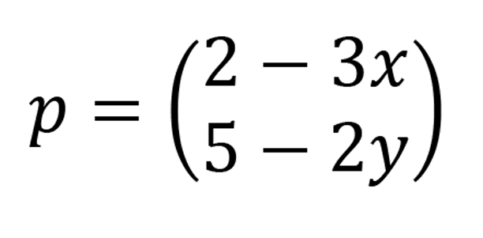

,

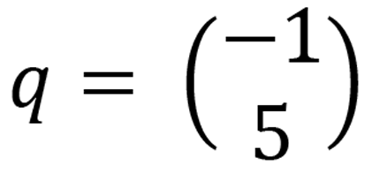

and

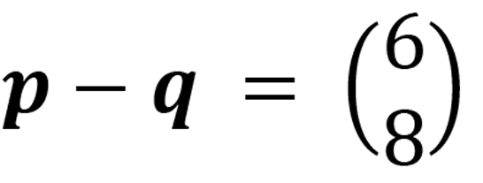
Find the value of (x + y)
(c)

(i)

Find the truth set of

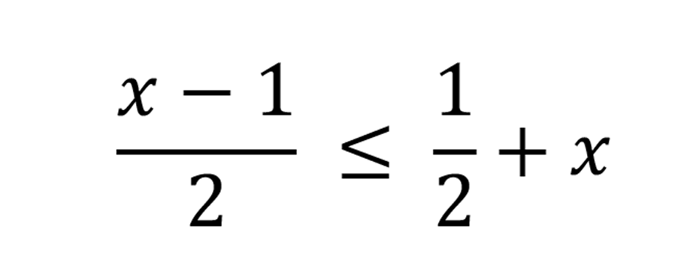

.
(ii)

Illustrate the answer in (i) on the number line.

6.
(a)

Copy and complete the table for the relation y = 5 - 2x for -3 ≤ x ≤ 4.
x | -3 | -2 | -1 | 0 | 1 | 2 | 3 | 4
y | 11 |  |  | 5 |  | 1 |  | -3
(b)

Using a scale of 2 cm to 1 unit on th x-axis and 2 cm to 2 units on the y-axis, draw on a graph sheet two perpendicular axes ox and oy for -5 ≤ x ≤ 5 and -12 ≤ y ≤ 12.
(c)

(i)

Using the table, plot all the points of the relation y = 5 - 2x.
(ii)

Draw a straight line through all the points.
(d)

Using the graph, find the:
(i)

value of y when x = -2.6;
(ii)

value of x when y = -2.8;
(iii)

gradient of the line.

